Project Initiation Document

## Introduction

The purpose of this project will be to create a learning analytics mobile application for optimising undergraduate students learning. The development of this idea has come from my personal experiences as a student. Without a real client involvement, I have found use for an application which allows individual learners to reflect on their activity and achievements in relation to others.

## Background and Motivation

As an undergraduate student and a leader within the peer-assisted learning scheme (PALS) I, myself and students that have attended my PALS sessions would have benefited from an application which would allow them to reflect on their own learning. This is used extensively in the fitness world with applications and wearable technology that allow users to monitor their progress and achievements for example ‘Strava’ and ‘Fitbit’.

The mobile application will allow the user to record activities and grades as well as set personal targets and compare their activities to others. All information provided by students will be private to the user unless the user allows friends access to their activity data. Some of the user's data, however, will be used anonymously in the back end to produce averages for comparison. The analysis of this data should provide insights and the tools to assist the users learning.

## Project Objectives

To deliver a mobile application with the following features:

1. Registration and login for different types of users
2. An interface that allows student users to log activities and grades
3. An interface that allows student users to track progress and time spent on different activities over different periods of time
4. Comparison of activities and achievements in relation to others anonymously
5. Allows user to connect with one another and track each others progress
6. Users can submit anonymous feedback to lecturers
7. An interface for staff users to track anonymous progress on their modules and any feedback

## 

## Initial Scope

Core deliverables

1. The mobile application
   1. Establishing a connection between the application and the database is the most fundamental deliverable. Without this the entire app will be unable to function as required.
   2. Developing an interface for student users to log activities and key dates.
   3. Developing an interface for displaying the data in different formats for the user to easily view and reflect upon their activities and achievements.
   4. Creating a registration and login system for student and staff users.
2. The database and backend
   1. To store all the data needed for my application and have it accessible for all clients.
   2. Keep clients update periodically with the current data.
   3. To calculate averages and other statistics on the collected grades for each user.

Desired features

1. The mobile application
   1. Developing a system for users to set personal goals and targets.
   2. Developing interface for staff to receive live feedback from students.
   3. Check-in to lectures using location services.
2. The database and backend
   1. Advanced statistical analysis

## Resources and Dependencies

There are no external resources and dependencies of note for this project.

## Method of Approach

The software development will employ an incremental approach, with X increments.

1. Users can record activities.
2. Statistical analysis of data performed.
3. Users can view their data in comparison to others.

Further increments to develop desirable functionality may be added dependent on time.

Thought has gone into the technologies that might be used on this project and a final decision will be made once further research has taken place. As the main focus of the project is a mobile application the choices are Android or iOS. It would desirable to have a cross-platform application but due to time restrictions on the project, development of one platform is realistic. I am currently leaning towards developing an iOS application using Swift and the Cocoa framework as I have iOS devices to test the application. For the entire back end of this project I am planning on using Firebase because as a tool it speeds up the development cycle. As a single developer firebase will allow me to create a fully functional app with all required features within the time constraints.

## Project Plan

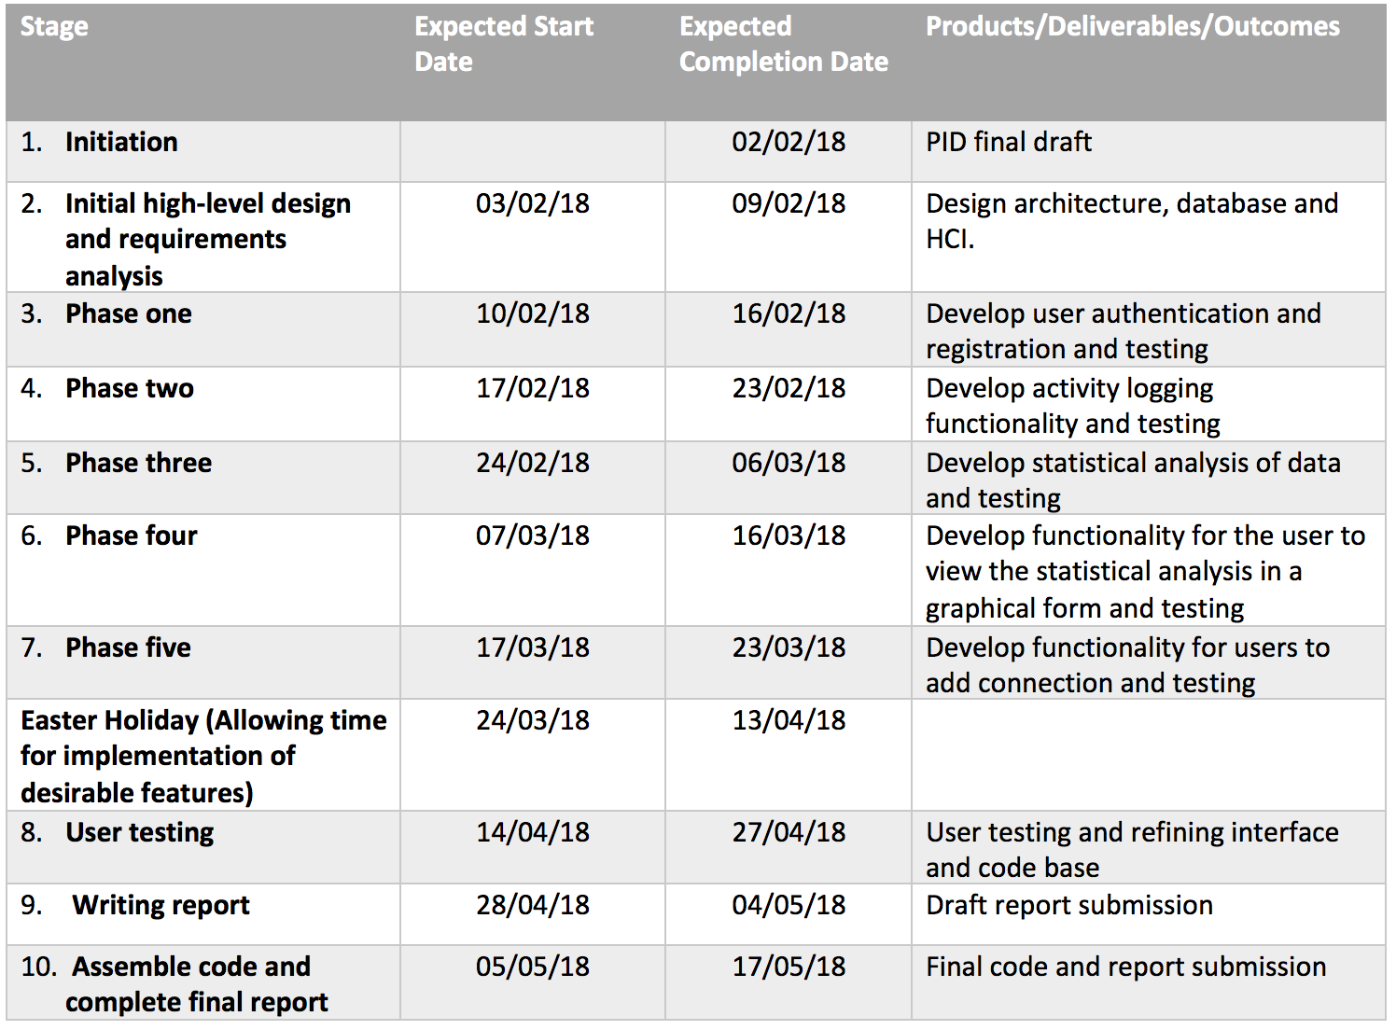

## Control Plan

The following control techniques will be employed:

1. Highlight reports to be submitted as described by the PRCO304 module brief.
2. Weekly review meetings with the project supervisor (Dr. Ismini Vasileiou) as described by the PRCO304 module. Additional ad-hoc meetings when required.
3. Risk management, communication plan, quality plan, and other contingency plans where necessary.

## Initial risk list

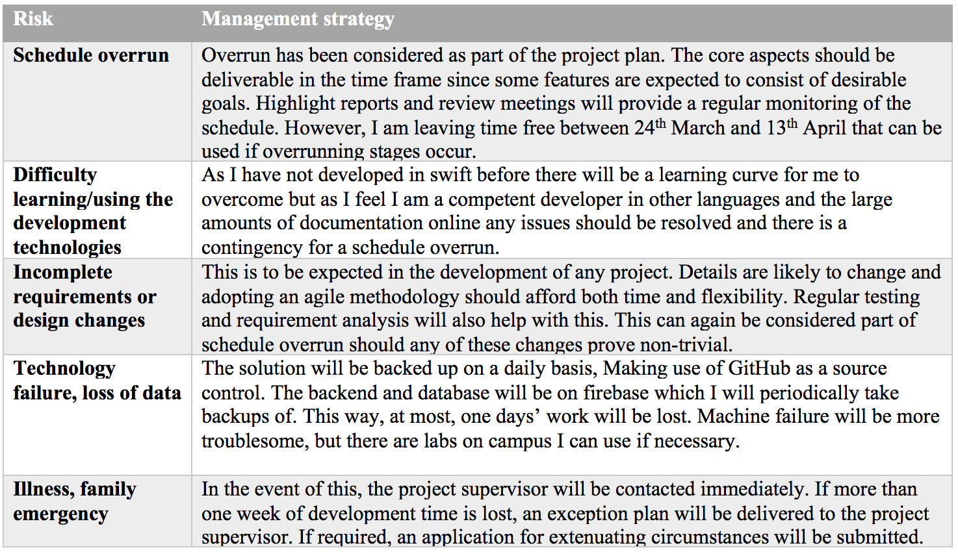

## Initial quality plan

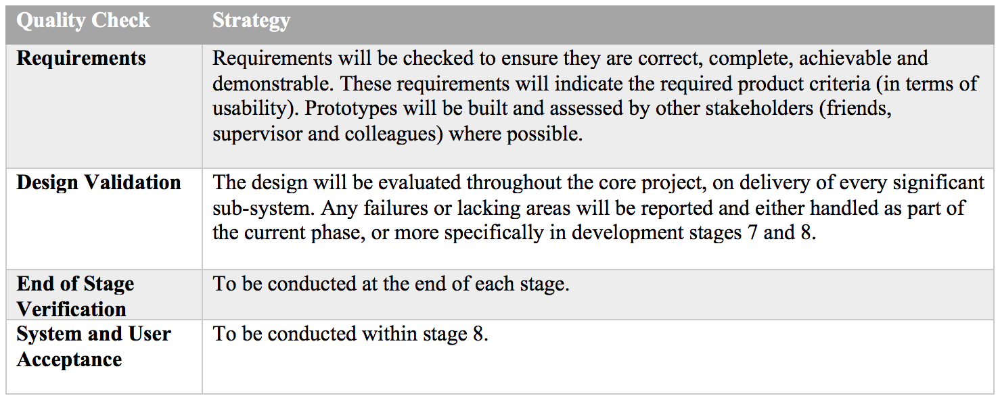

## Legal, Social, Ethical and Professional Issues

The main ethical issue that arises within this project is the storing of user-data. This data could include personal email addresses and passwords used to register, as well as other personal details provided by the. This is one potential benefit of using 3rd party authentication services for registration as Firebase has its own authentication service. Users would only have read and edit access of their own details and I plan to encrypt user data before being sent and stored in the database.

The main social issues that could be encountered with this project is a risk of de-motivation of users that maybe below the average mark. This will be countered by allowing the users to only view their own data and monitor their performance without being compared to others.